Access Review Committee: Revised guidance on ‘participant/patient/public involvement’

Public and patient involvement is essential for translating scientific discoveries, made using participant data held by Genomics England in the National Genomics Research Library (NGRL), into patient benefits.
By ‘public and patient’, we mean individuals with lived experience of a health condition — whether they are participants in the NGRL, current patients or former patients, or carers) — as well as, in some cases, representatives of patient advocacy organisations.
By ‘involvement in research’, we refer to the National Institute for Health and Care Research (NIHR) definition, which emphasises that research is conducted ‘with’ or ‘by’ members of the public rather than ‘to,’ ‘about,’ or ‘for’ them. This involvement represents an active partnership between participants, patients, carers, and researchers, allowing them to influence and shape the research.
Embedding public and patient involvement in your research
If you have partnered with patients or the public, highlight any groups you have worked with or plan to work with, including discussions with those who may benefit from the research.
Although not exhaustive, examples of public and patient involvement include consulting on research design, co-developing information materials, or sharing research findings with relevant patient groups and communities.
The pathway below illustrates how public and patient involvement can be integrated throughout a research project, ensuring patient and public perspectives are central at every stage.
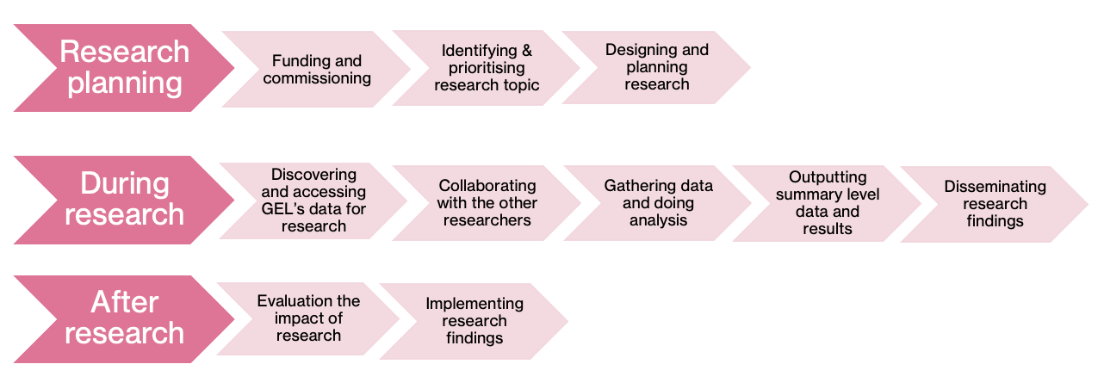
While meaningful public and patient involvement may not always be feasible in the early stages of the research pathway – such as during target selection when a specific patient population has not yet been identified – efforts should be made to involve patients and the public at later stages. In such cases, please outline your plans for involving patients and the public once a relevant population has been identified.
We therefore ask that you provide the following information in your application:
- How have you involved the public and patients so far?
- How will you involve the public and patients going forward?
- If you do not plan to involve the public and patients, please explain why.

Useful resources
- Briefing notes for researchers - public involvement in NHS, health and social care research (2021): https://www.nihr.ac.uk/briefing-notes-researchers-public-involvement-nhs-health-and-social-care-research
- UK Standards for Public Involvement (2019): https://sites.google.com/nihr.ac.uk/pi-standards/home
- Imperial Experience Research Centre - Public Involvement: https://www.imperial.ac.uk/patient-experience-research-centre/ppi/
- Rare Disease Research UK – Patient and Public Involvement and Engagement resources for researchers
https://rd-research.org.uk/resources/

