The Motherhood Group x Genomics England:

Black Mums Supporting Babies Workshop

Report

Introduction
On the 10th of July 2022, The Motherhood Group held an in-person workshop in collaboration with Genomics England to understand Black mother’s responses to a pilot study seeking to identify rare genetic conditions in babies and monitor these conditions throughout the child’s life.

The workshop facilitated an understanding of the hopes and fears Black mothers associate with the research project. Participants watched a short video provided by Genomics England and heard about the study from the facilitator, Sandra Igwe, accompanied by two representatives from Genomics England. After discussing the study and video thoroughly, the workshop progressed to exploring influences on decision-making when considering participation in the study. Participants were encouraged to co-design materials for engagement and recruitment for the Genomics England study, informed by prior discussion and making use of both in-person and online media.

This report presents the findings and recommendations from the workshop. First, the methodology is discussed, before addressing the hopes and fears associated with participation. The third section explores influences in decision making. Lastly, co-designed materials for engagement and participation are presented. Recommendations are highlighted throughout and compiled in the conclusion.

Methodology

Sample
In total, 37 women signed up to attend the in-person workshop through Eventbrite. Of these, a proportion showed up to the in-person event, many accompanied by their children. The slightly smaller group size provided a more intimate space for discussion. The workshop took place on a Sunday, meaning some participants may not have been able to attend due to childcare, religious or other responsibilities. With online recruitment for events, it is often the case that the attending sample is smaller than the number recruited. It was estimated half would attend and the room was prepared for the appropriate number of attendees.

Tables were set up in a conference style where all mothers could see the screen onto which the video was projected. Materials included paper, coloured pens, social media templates (including representations of Instagram posts and YouTube videos) and a test brochure provided by Genomics England.
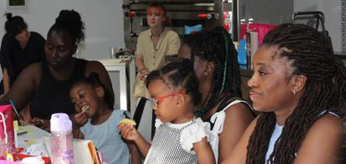

Consent, Confidentiality and Recording
Participants were thanked for agreeing to participate in the study after consent was given. Participants were informed of confidentiality and recording. All mothers were reminded to prioritise their comfort when it came to discussion points, ensuring they reflected on how the topics were affecting their feelings. Another room was available for those who wished to take a moment away, though none of the participants needed this facility.

The workshop was recorded using a small hand-held voice recorder. This allowed some transcription of the discussions, however, because of the number of children present and echo the recording was unclear due to high noise levels. The transcript attached in the appendix generated through NVivo highlights the issues in recording. However, when the audio file was cross-referenced against hand-written notes key themes and recommendations could be found. Despite this, many participants expressed the ability to bring children to the event was useful, allowing them more freedom and availability to take part. Participants often referred to their children who were present when discussing medical testing and research. Hand-written and typed notes were taken during the workshop to capture key themes as they emerged.

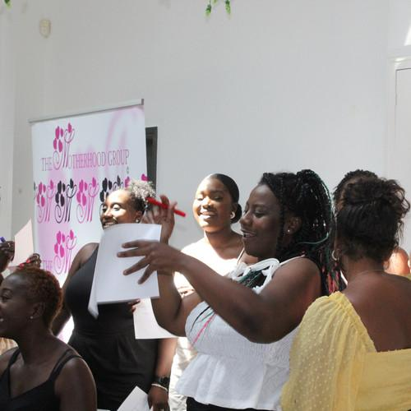
Contextual Background to Pilot Study
An introductory ice-breaking game was used to offer space for mothers to get to know one another before the session started. Context and background to the pilot study was then offered with the following contextual basis:

“We estimate that every day in the UK, 9 babies are born with a rare genetic conditions that could be treated, prevented, or even cured if only people had been able to diagnose them when they were newborns. The main aim of this study is to see if we can use new technology called ‘whole genomic sequencing’ to find these babies at birth, and link them to the right support networks to help them and their family live their best possible life.”

The importance of listening to Black women’s experience and the value this will add to the pilot was highlighted before introducing the video.

Genomics England Video and Discussion
The video provided by Genomics England was paused at pre-agreed intervals. During these intervals, participants could ask questions about the information provided and share their thoughts, offering insights into their hopes and fears and allowing collaborative exploration of the emerging themes. Six A3 stills of the video were attached to a wall where participants could place post-it notes with their thoughts. The following prompts were provided:

- What types of stories/myths come to mind?
- What are the barriers to taking part?
- What are your hopes for your children if they were part of this programme?
- Do you hope this programme can help with any specific conditions or inequalities? Which ones?
- How do you see yourself served and represented by this programme?
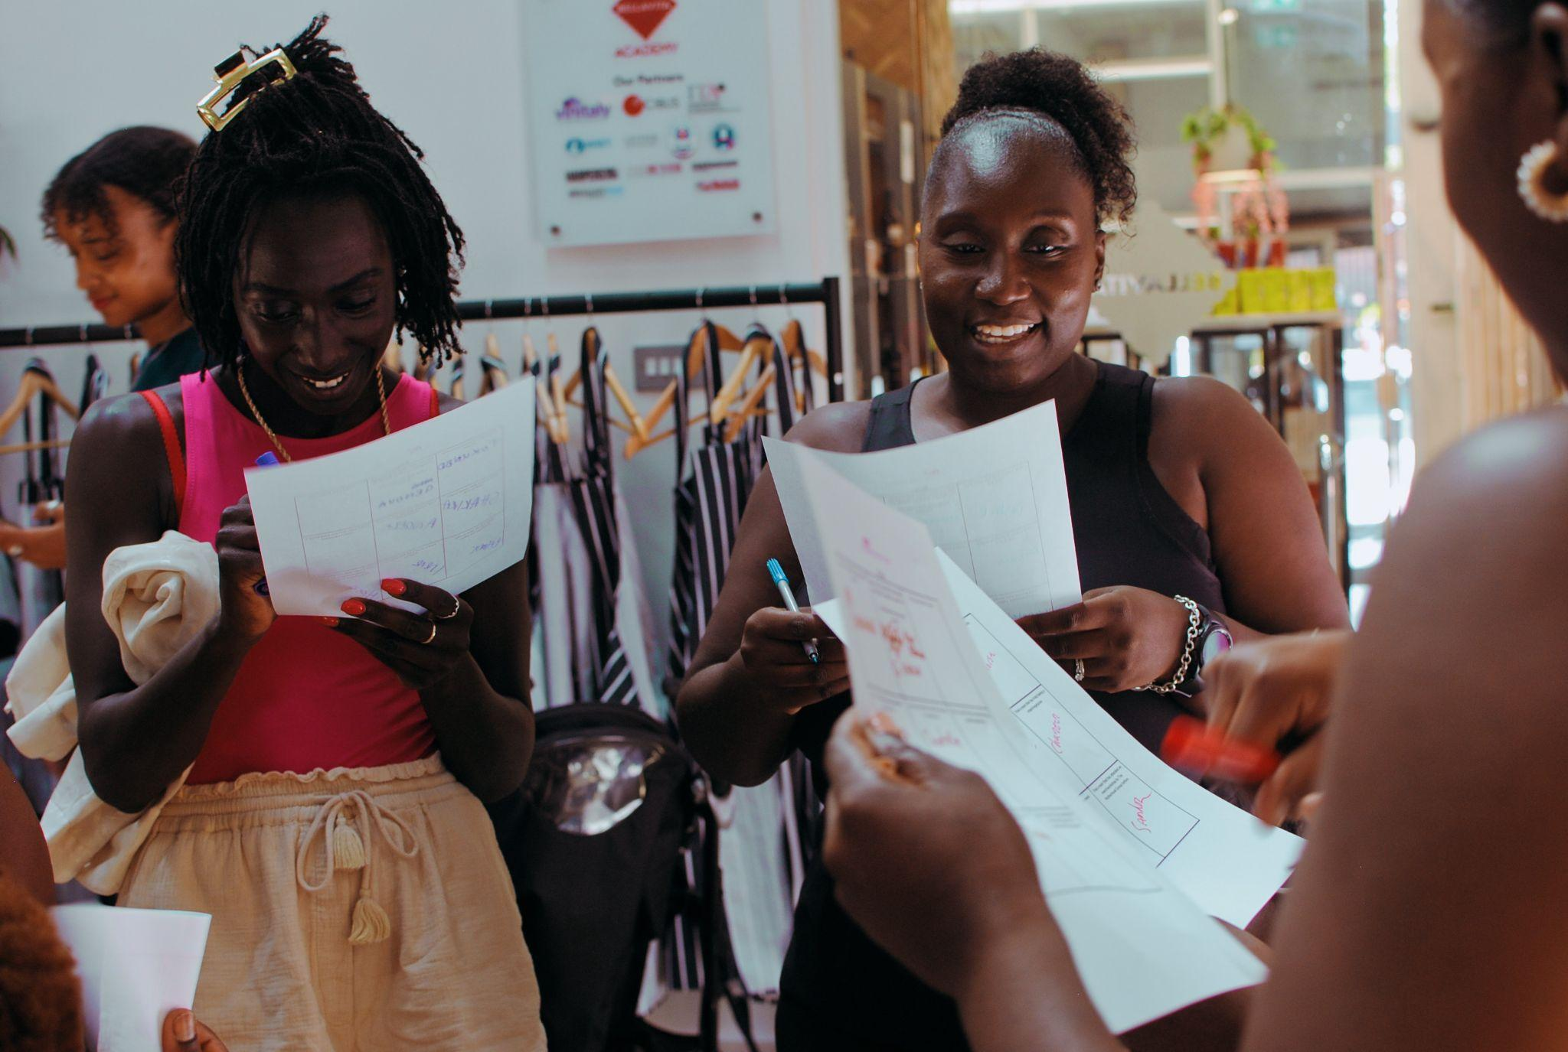

Group Discussion: Messaging
After the video and discussion, the following questions regarding messaging in the video and brochure, alongside further information provided, were presented to participants:

- What do you need to know?
- What vocabulary resonates/does not resonate?
- Where should this show up, and from whom?
- What might sway your decision to take part?
- What hopes and fears about this study come up in the community context?
  - How might these be alleviated?
- What formats (and messages) would be most appropriate or successful in helping mums involve their partners, friends and family in deciding to take part?

Some of these questions were discussed orally, where participants could ask each other questions and hear the perspectives of their peers.

Creative Co-design Activity
Some of the questions also fed into the third activity involving a creative task. The following prompt was provided by the facilitator for the creative co-design project:

“We’d like to see what types of materials you might want to have access to in order to have a fact-based conversation about taking part or not with anyone who might be supporting you in making your decision –whether your helpful partner, wise sister, nosy uncle, or trusty friend.

First, you can pick a format – maybe it’s a TikTok video, maybe it’s an Instagram campaign by your favourite influencer, maybe it’s a magazine article or a set of cards, a quiz?

Using the materials provided, create your resource with maybe one or two or the messages or facts that would make it easier for you to make your decision

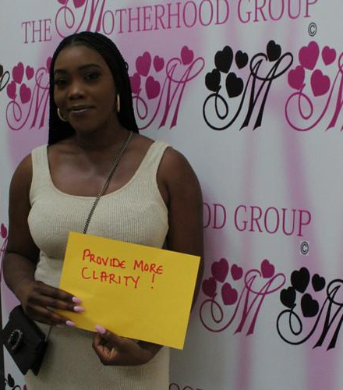
If you need any help with what to write or which message to pick, have a think about the discussion we had earlier, have a look at the leaflet and feel free to speak with those around you.”

The creative co-design process lasted approximately fifteen minutes before sharing with the group. The activity also aimed to understand what materials may help to facilitate conversations about taking part with loved ones.

Lastly, participants were asked to write advice for the Genomics England team on A4 paper. These were photographed. They included reflection on representation, safety and cultural awareness.

Methodological Reflections
In assessing this workshop against others coordinated by The Motherhood Group, we found some level of reluctance to identify specific cultural barriers to participation and the effect of race or ethnicity on engagement in the pilot study. For example, during the Advice session, where participants were asked to write take-aways for the Genomics England team, a participant noted she would like to hear this information ‘from someone who looks like me’. It is worth considering the value of spaces in which Black women can feel free to express their hopes and fears, discussing the often complicated nature of lived experiences of racism and racialisation separate from White people. When the participant mentioned was asked to share her advice, she apologised to the two representatives from Genomics England as if she may cause offence through her suggestion.
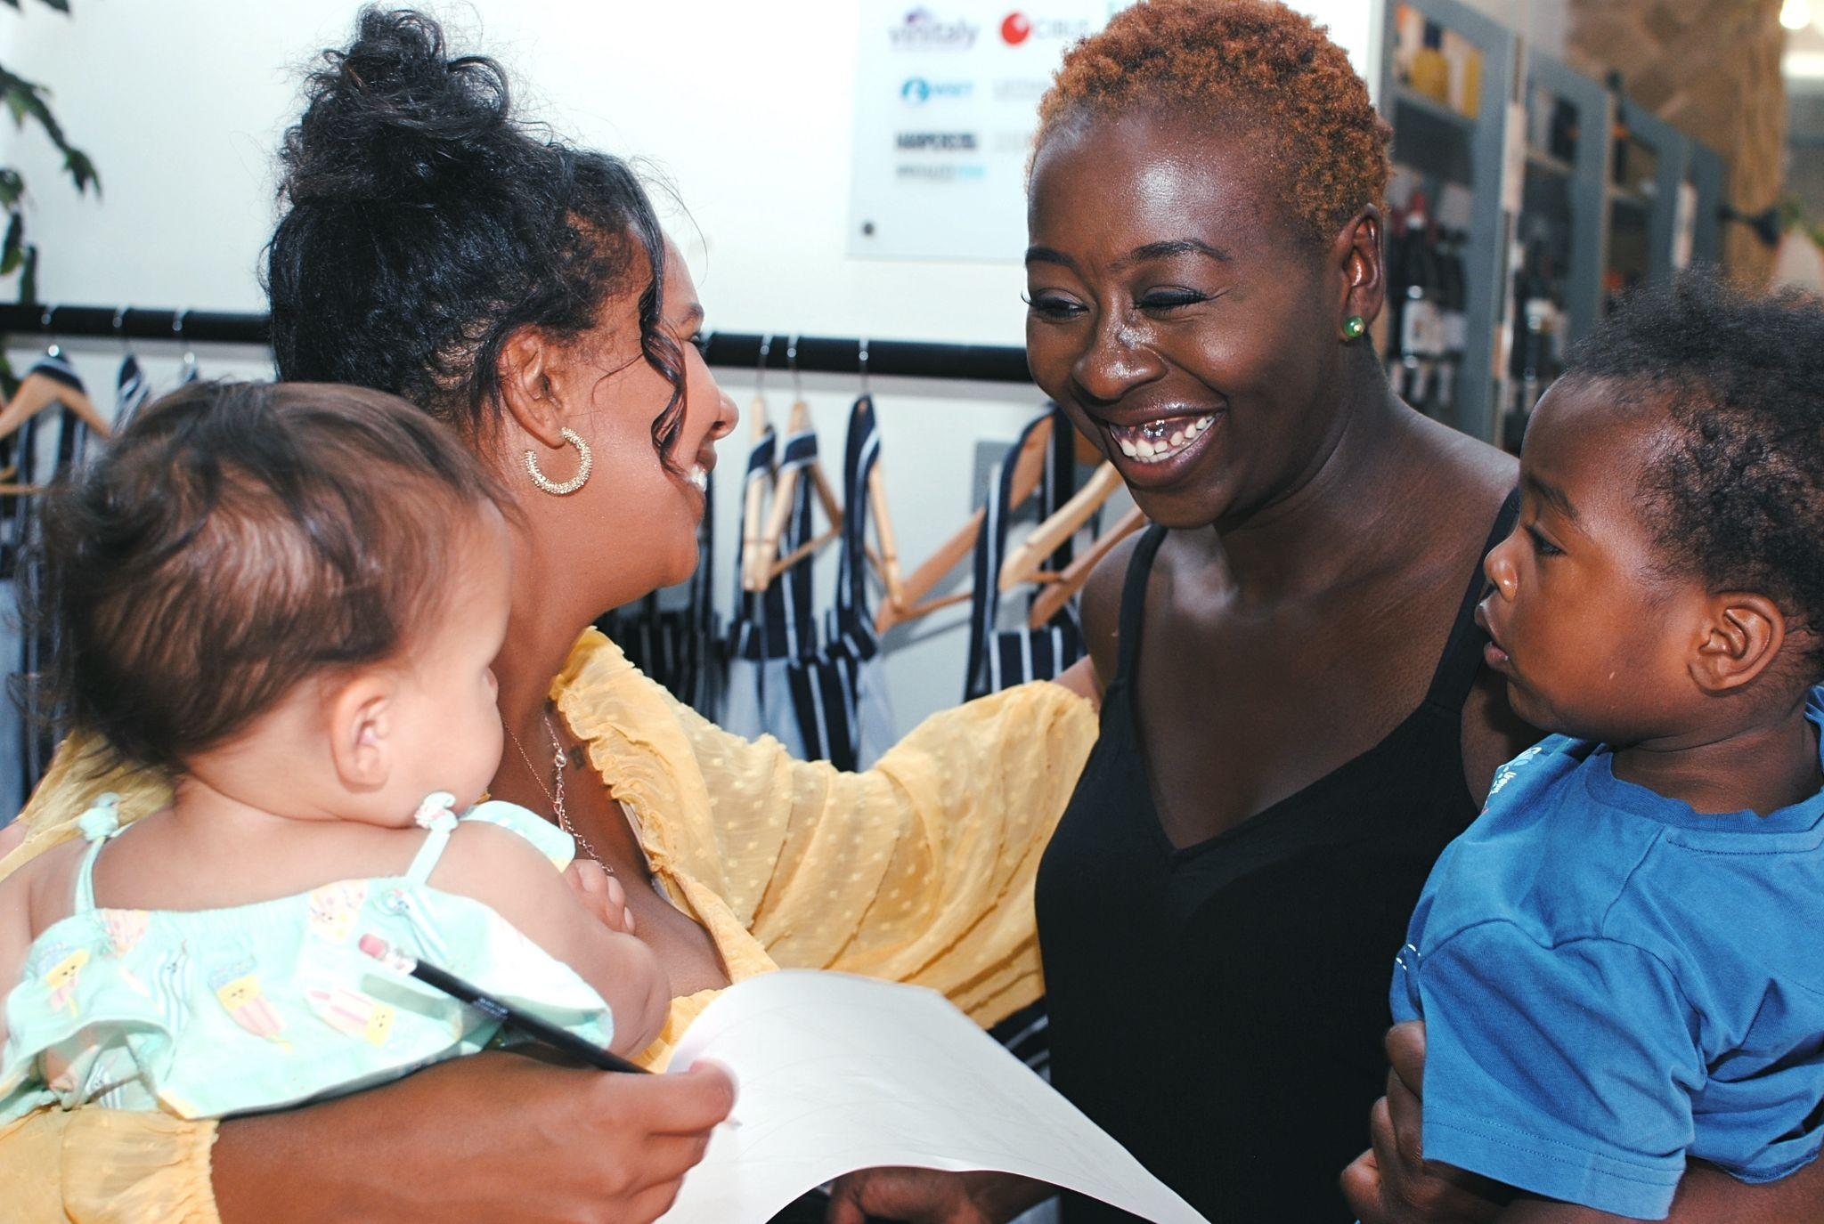
Although it was useful to have representatives from Genomics England present for clarification purposes, there may have been an effect on the outcomes of the workshop – how open and honest participants felt they could be.

Furthermore, the video used to cue discussion did not foster much excitement.
One participant stated:

“The beginning of the video was too professional, I zoned out so many times”
Recommendations:
- Encourage diverse recruitment within the Genomics England team and representatives for recruitment and outreach events to foster trust in the study and ensure those who feel more comfortable speaking about cultural, religious or ethnic barriers have every opportunity to approach someone they feel may better understand.
- Design materials for the communication of information with participants who understand the context of minoritised communities, including grassroots groups, to gain a more nuanced understanding of the hopes and fears associated with participation.

Hopes and Fears

This section explores the hopes and fears associated with the pilot study. Participants were more likely to identify fears as they addressed their questions and concerns. Fears are addressed first, followed by hopes. Recommendations can be found at the end of each subsection and are consolidated in the conclusion.

Fears

Fears about the pilot study centred around feelings of putting the child at risk or pain or discomfort; having one’s baby taken away for too long immediately after birth; an overload of information, given the amount of information already shared during labour or pregnancy; lack of preparedness; questions of consent; causing trauma to the mother; questions about continued support; further burdens on the NHS; incomplete information; feeling like a guinea pig as an ethnic minority for services which have not been tested; inability to develop a cure within a mother or child’s lifetime; lack of continued information and updates about the child’s health; questions of funding; knowing a child has a genetic condition and not being able to do anything about it.

The fears expressed by participants in response to the video provided by Genomics England are discussed in this section. For clarity, three key themes have been identified encompassing the aforementioned concerns. They include:

- Physical or psychological pain or discomfort to the child or mother
- Information overload and questions of consent
- Concerns over continued support

Physical or psychological pain or discomfort to the child or mother
Drawing on their experiences of birth within the NHS, many women expressed concerns over the number of tests their newborns are already subjected to immediately after birth. One participant expressed her preference for all of the tests to be done together as soon as possible to minimise continued intervention. This was met with responses indicating an overall concern about how the newborn might experience pain or discomfort and the psychological harms this might cause to women who have just given birth.

“Are you feeling less anxious if they’re doing all the tests at once? Ultimately, they’re still the same tests and you’re still looking at [your babies] faces. It’s one thing after another”

Although most women did not want to make repeat visits to the hospital for further tests, they also did not “want them poking my child”. Taking blood from the child was perceived as a primary fear in the mode of collecting the substances needed for genomic sequencing.

“I don’t feel comfortable taking blood as soon as they’re born. Thinking about pain, it’s going to hurt the newborn”

“I’m always anxious around tests. Obviously the baby is going to cry, it’s going to be painful and the mother will be anxious. Perhaps if it was explains in advance then the mother would be more prepared”

“It’s overwhelming having the baby’s blood taken. The notion of giving blood is traumatising because the professionals say they have to do it, there is nothing they can do. It has to be done”

One participant felt she would be more comfortable having her child’s heel pricked some weeks after the baby is born. However, the delay may also cause anxiety, as information about potential illnesses or conditions may be delayed. Whilst it might be better to get this information as soon as possible, the process of testing caused unease primarily due to the mother’s empathy and awareness of their child’s sensory experience. Some participants had experiences related to child blood testing which they felt caused trauma. This was primarily caused by a lack of information as to why so much blood was being taken, feeding into concerns regarding information overload and consent. Participants desired clarity over whether it was beneficial to do the tests immediately after birth or whether they could have a delay in testing.

Recommendations:
- Clarify whether and why the substances for genomic sequencing must be taken soon after birth.
- Ensure the child is not taken from the mother for too long after birth, or that mothers can decide how soon after birth substances are taken for genomic sequencing.

Information Overload and Questions of Consent
During pregnancy and birth, mothers and mothers-to-be are inundated with large amounts of information regarding risk, safety and testing. This led to feeling a lack of preparedness for what will take place after birth. As this is a pilot study, participants also felt that they might be given incomplete or potentially inaccurate information about their child’s health.

“If you had a C-section or a natural birth there is so much information and you do need to get information about what the tests will involve”

“Giving birth in lockdown, they gave loads of information to begin with but I didn’t have time to process. Unfortunately, services don’t have time to sit down and explain everything”

“Don’t give information that’s not complete, especially when it comes to my children. The information needs to be accurate. Take as much time as you need to give correct information”

Key questions about information provided included:
- Do they keep the information of everyone that has had it done? Or just the children?
- Why would they keep this data if the child is healthy?
- If data is anonymised, how will they update us about our child specifically?
- How does it benefit me if they’re only updating me about the study and not my child?
- How are they going to fund this study?
- How will they make sure everyone is able to take part?
- How are you going to reach ethnic minority communities, rather than just wait for them to come to you?

When receiving results of testing, participants would prefer in-person conversations with a GP so they can ask questions for clarity, rather than receiving results by telephone or email. One participant hoped this conversation could take place in her home, but understood the resources may not be available to realise this mode of communication. Results and appointments should be timely to avoid increased anxiety with long waiting times.

“It needs to be not three weeks' time, it needs to be as soon as possible. The information should be an urgent appointment, not later on. Though this sounds good, it feels like a fairytale knowing how understaffed the NHS is right now”

“A phone call saying you need more tests would make me really upset, it’s much better to have a face-to-face conversation”

Additionally, there may be information about their health pregnant women want to offer to support a healthy birth of their newborn. This can include conditions women know they have which they worry their child might inherit, such as cystic fibrosis or sickle cell.

“I wish they would have done the tests when I was pregnant. I told them about my illness and they didn’t do any tests to see if my baby might have it. The prospect of having a child with cystic fibrosis scared me more than any injection”

“The father of my child is a carrier of sickle cell but did not know it, it was very important for them to do a test to know if my baby had it”

“When I was pregnant we both had half of something that could make my child have sickle cell. I was already pregnant and it was the scariest moment of my life. Even when they did a test and found she didn’t have it I was still afraid. There’s so much we have to deal with as black women getting pregnant, a whole life shift and the advice of aunties and family members”

The video also raised serious questions about consent and choice in participation. Although it was clearly communicated that participants would be given a choice about their participation, how this would be communicated and methods of revoking consent raised a barrier.

“Mothers should have a choice about whether they do the prick or give blood tests straight away or wait a while, unless there are particular concerns which have been highlighted when pregnant. They shouldn’t just tick a box and sign”

“The choice depends on the birth experience too. You can withdraw any time with emailing or calling but with a traumatic birth emailing or calling will not be on your mind. I want to be able to say no to somebody and know it will be taken seriously”

Furthermore, black women’s understanding of the exploitation of their bodies for medical testing and intervention caused fears over feeling like a ‘guinea pig’ in this pilot study and some women questioned where funding for the pilot derived.

“I already had a low level of excitement about this study, but hearing the statement about ethnic minorities brought this excitement down. This partly has to do with what we know about the health services and changes that have not been made. Feeling like a guinea pig for services that have not been tested. If genetic testing brings up issues in my community I need to know what needs to be done will be done. There is little funding for issues concerning ethnic minorities. How is this going to be different? Putting my child through something that may not even benefit my child or my children’s children”

“Not everyone should have to be part of this test, but it does sound like a test. As black mothers we might feel a certain way about it but in the end they have to test it on somebody. It should be a choice, I should be able to decide if I want to take part and change my mind anytime even through using my voice. Not just an email or phone call”

Overall, this pilot study should be situated within a context of birth in which women are already receiving large amounts of information. For Black women in particular, it is important to clearly indicate choice in participation and allow consent to be revoked as simply as possible due to the complicated histories of Black women’s involvement in medical and scientific research. In order to show the benefit of the pilot study, further engagement with Black mothers should be considered, in spaces where Black women feel free to speak openly about their concerns. This will allow greater attunement to the specificities of the cultural barriers to participation and may broaden an understanding of the conditions or illnesses of greatest concern to Black communities.

Recommendations:
- Ensure practitioners taking samples are aware of the burden or testing on newborn babies and mothers and there is clarity and understanding about what the samples will be used for.
- Ensure communication can take place face-to-face to discuss results of testing.
- Ensure women can raise concerns about genetic conditions or illnesses they have particular concerns about. Women should be informed whether or not the genomic sequencing will be able to test for these conditions or illnesses before giving consent.
- Ensure women are able to verbally revoke consent at any time, including those who have consented to participation before birth but do not want substances taken immediately after birth.
- Ensure clarity over funding of the project and realistic projections of the impact of the study for minoritised persons.
- Carry out further engagement research to understand the specific cultural barriers to participation and conditions or illnesses which most greatly concern Black communities. This engagement should take place outside of the white gaze.

Continued Support
Lastly, within the context of an already overburdened NHS, many Black mothers wondered how it would be possible to offer adequate continued support for their child if diagnosed with a genetic illness or condition as a result of participation.

“On face value, saying they’ll do the test earlier and give support is good, but we need details about what that support will entail, what do we have to do to get that support?”

“This sounds good, but it feels like a fairytale knowing how understaffed the NHS is right now”

“The support for the baby may not last. The study might take priority and not support the mums and babies”

“We need to know what they’re going to be tested for and what support specifically looks like”

More than one participant worried they may find out her child has a genetic illness or condition and is then left unable to treat it. This was explicitly linked to the potential for those carrying out the pilot study to raise expectations around its impact.

“It’s all well and good to say find out early and we will support you and potentially cure your baby, but it’s a step too far. If you can do it, just do it. Don’t tell me you can do it if you’re not able to. Don’t raise my expectations only for them to be shut back down again. At least then I can digest the information, don’t give me false hope”

“I fear knowing my child has a genetic condition but not being able to do anything about it. Is this part of the NHS or something to support the NHS?”

“When they say they can cure genetic conditions I do wonder ‘how’? I’m excited but sceptical?”

“It’s the aftermath, after you’ve done all this testing, how is it going to be addressed and going to be treated? In black and ethnic minority communities there are issues like short staffing, and how are they going to find more? How is this going to be treated?”

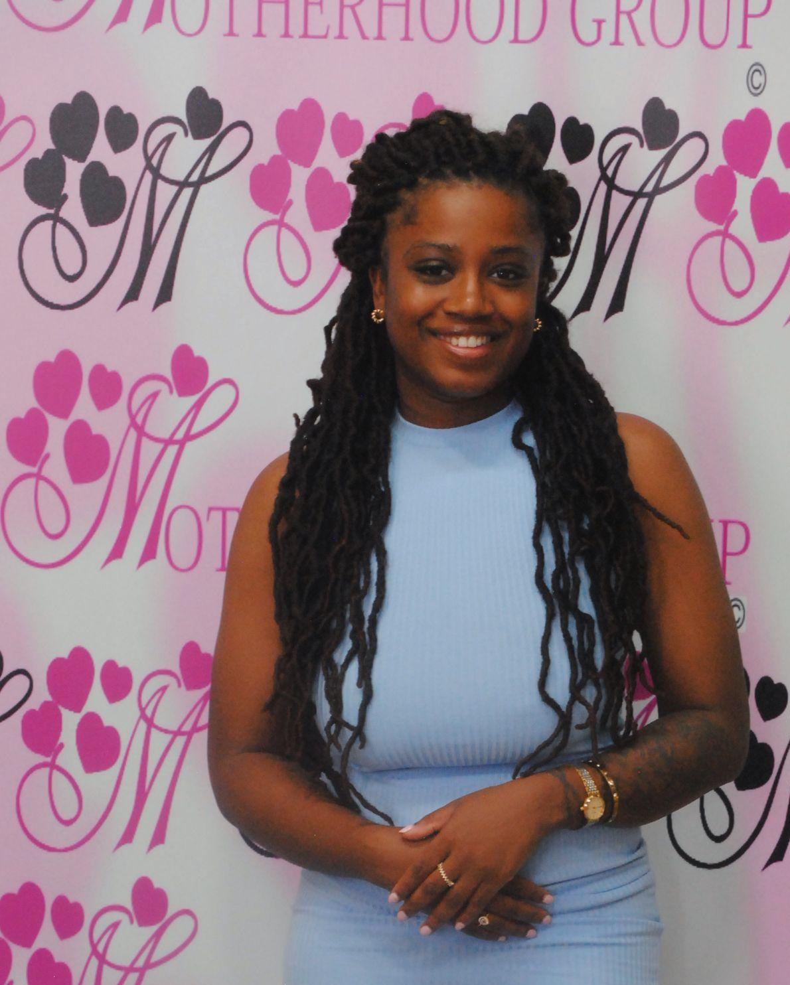
Recommendations:
- Clarity should be provided over how specifically NHS and other services will provide continued support for mothers and babies who consent to take part in the study.
- Expectations surrounding what genetic conditions or illnesses may be identified and which can be treated should be clearly communicated before free consent is given.

Hopes

Hopes about the pilot study centred around identifying lifelong conditions, including sickle cell; excitement about participating in a pilot study; improvements to medicine in the distant future; personalised care; contributing to a research programme that will help people from within their community.

This section explores the hopes expressed by participants through the following two themes:

- Excitement about participation in the pilot study
- Identifying lifelong conditions

Excitement About Participation
Excitement about participation was often framed around the long-term impact of the study. Participants saw how their involvement may improve medical understanding of genetic conditions and illnesses, but saw this as happening in the distant future rather than impacting their or their children’s lives. Thus, comments about the impact and excitement were often placed alongside a scepticism about direct impact.

“They’re not saying they’re going to cure [conditions/illnesses], they’re saying we want to look at your genes and see if we could possibly ever cure something”

“I don’t think they’re really going to cure these conditions, but I guess it’s for the future of medicine, even in 200 years time”

“The kids they are testing probably won’t benefit. Really, it’s to gather data so in the future they can find out more. For our descendents, not for us”

However, the long-term nature of potential results was also conceptualised as affecting their child’s life after childhood, as the quote above indicates, improvements for descendents was seen as a positive and hopeful aspect of the pilot study.

“We don’t think about it all the time, you also want to think about your children’s children”

“It’s like the Geneva Convention, what are you doing to make things better so my children’s children don’t have negative experiences?”

“They do this research to help humanity, rather than you in particular. It’s transactional”

Identifying Lifelong Conditions
Another hope expressed by participants was that the study could help them to identify lifelong conditions their child may be living with. This was presented alongside the idea that adequate and continued support would be needed to meet their child’s needs if any diagnosis was to be made. The excitement and hope here was thus also often framed directly alongside concerns and fears mentioned in the previous section.

As explored in Fears, information about conditions or illnesses is perceived as beneficial, provided the information is communicated effectively, preferably face-to-face, and the conditions the genomic sequencing are testing for affect Black communities.

“Contributing to this research programme could hopefully help people from our community”

Recommendations:
- Emphasise the impact on the future of medicine and understandings of genetic conditions.

Taking Part: Co-designing Materials for Engagement and Recruitment

The second part of the workshop involved engaging Black mothers in thinking about their influences in decision making and co-designing materials for engagement and recruitment. As explored in the Methodology, there were numerous creative or writing-based options available through which participants could share their ideas.

The images in this section provide an indication of the types of materials Black women may find useful or compelling when receiving information about the pilot study. They also indicate some of the key concerns addressed by participants during the session. Ideas ranged from Instagram posts collaborating with influencers in the Black motherhood space to in-person events at large venues where representatives from Genomics England could speak one-on-one with potential participants.
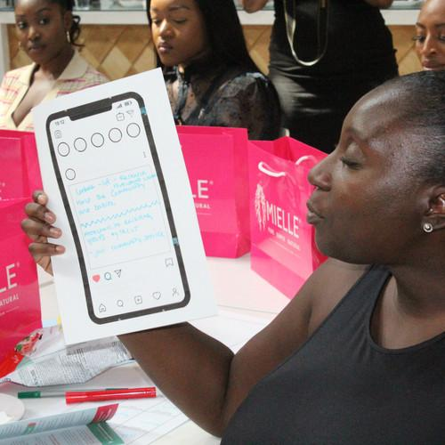
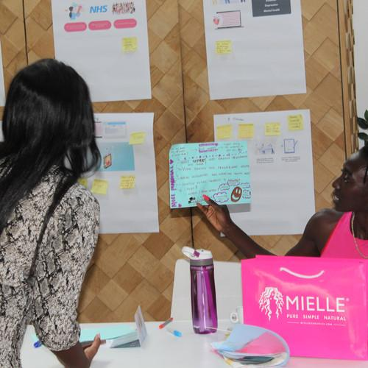

What would be the best way for you to receive this information?
Through co-designing materials for recruitment and engagement we were able to see what kinds of messaging are most effective amongst our participants. Most participants agreed that in-person events could be an effective way to learn about the Genomics England pilot study alongside friends and family who might also have an influence in decision making. Significantly, as mothers, many participants felt learning about the test and being able to ask questions alongside other mothers would be an effective mode of engagement.

Below are two excerpts from the transcript in which separate participants speak about their in-person ideas for engagement and gathering information:

“My solution was 'mother's evenings' so that was the forefront of my solution here yes, this right now [the event] is much better than if I saw that video. So if they went for every borough because I don't know if this is a borough thing and they had this kind of thing, and understanding that, maybe we can bring out little one's as well, I think that's the best way to get people's foot in the door so if you let us come, if you let us bring our children, that's another foot in the door and then we just get powerful information”

“So this is a hub. Like the Excel Centre. Maybe have a screen that kind of addresses everything explained because obviously I feel like there's different learners and obviously diversity everyone learns differently for some people that is useful for them if they want to watch a video. So maybe like a video kind of showing that you know like when you go to Excel, when you presented it so like there's a screen, people are talking and then there's like different like stations like these stations for like wheelchair accessibility, people that want to get information this this one is for people that want to get their information in the post, that can provide them a postcode and address and stuff like that. And then this one's for people that kind of just want to get more into social media, they want to keep their apps, they want to speak to other people. And then kind of to just kind of like a, in terms of like what one of the ladies were saying earlier about, like when they when they're they're getting information, they want to feel comfortable, they don't wanna always, saying like, she wants to feel comfortable, she doesn't want to feel like you're not making information. So maybe that this section is kind of like a chill area where it's like people can help the ladies, you guys kind of walk up to people and approach with this have general conversations so not heightening anxiety.”

In giving suggestions, participants also stressed the importance of having representatives ‘who look like me’, those who are more likely to have a greater understanding of histories or racism and racialisation and their connection to healthcare for and experimentation on Black women’s bodies.

“I wouldn't even say historically because the 1960s is not that long ago. But, um I know that typically, black women have been seen as the most tolerant in terms of pain threshold [Indistinguishable] and it's frustrating, you know, they want to know what is our limit? They think we can have Caesarean without being under, so you're kind of like, we need them. They need us. But that is like our mothers told us, our grandparents told us. So we're all entering into this space that's shared a bit rigid. I consider I was somebody who was concerned, like, who doesn't want to know if their child, I think they have the responsibility to give that information rather than us find it ourselves, that's what we're doing. That's what black women do, find that information and do it ourselves.”

For social media-based outreach, participants wanted someone who has lived experience of motherhood or pregnancy to represent the study, speaking about why it is important to them before offering a click-through to find more information on the Genomics England website. This sometimes also included organising an in-person event, where those who have found information online or through social media can come and ask questions.

“Like Instagram to be like, reshared, for Facebook to Instagram, or short video for women who have a baby with a rare condition explaining why this type of research is important. You've got someone there with lived experience that's going to be very interesting. And within that you've got a nice click link which takes you to the website, which has more detail about what the research involved with organisation. And then to go further from that workshops with certain networks of communities, especially communities where they target like representing certain random ethnic, black and brown women, that you're being a bit clever and that will engage people like myself a little bit more so user yourself and organisation and partner with a range of different communicate We do workshops to increase cases where you wouldn't necessarily have individuals that will know about this piece of research, both online and face to face or give both options”

“I put: list why still, I still got one who might not want to take part in the data and bust any myths. So, you know, perhaps you're worried about this. And perhaps you think about this. And that's something that you've had in the past. However, with our, with our programme, it's different because of these reasons. Also explain the effect of not having the programme. So basically saying how it's beneficial, kind of making people before encouraged to partake in the programme. And then also talking about how having a programme does help. So there's just multiple ways to do the same thing that makes sense. I think repetition is always going to get people on side. What incentives are there for taking part in exactly what happens to your data? Why it happens? When does it happen? How does it happen? How long does it happen before? After the child is 16, you ask them if they want to be part of it. Why is that? Have ambassadors so mothers who have decided to take part and just regularly talking about why they, took, decided to take part, what's actually happening with them in their lives, how it's affecting their child and how it's benefited them. So people can actually be listened to what it's like for one person rather than just someone coming along, saying, if you do this for us that we'll be able to do this for everyone. And then again, I just put some different ways like to make it a bit more interesting, because to me, that video would never make me sign up. But if you maybe had a community like this, and I got to hear so many different ways that you are applying, also people that I really love to follow online. What are their stories, you know, sort of like ambassadors, And taking part, and I feel like for me a lot of my knowledge before I had a child came from online classes before I went to one of those, and then I felt I came out, like supported with this knowledge. Prior to, for most women, you don't learn about any of this stuff in school, you don't really learn about it from your parents, you don't know what you don't know. And then when you you're sat there and you are told these terms and basically... Tiktok videos and all the stuff you were saying”

Further visual imagery outlining methods of outreach are included in the Appendix.

Conclusion

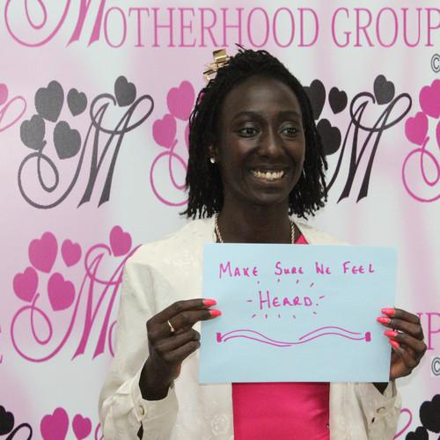
This report has detailed insights gained from The Motherhood Group x Genomics England workshop; Black Mums Supporting Babies. Overall, primary fears about participation included fear of physical or psychological harm to mother or child, information overload and issues of consent, and anxieties over the promise of continued support if a mother’s child was diagnosed with a genetic illness or condition. However, participants also had hope that the study might influence the future of medicine, creating a better world for their children and children’s children, even if they did not see results in their own lifetimes. This was influenced by the ability of the study to identify lifelong conditions. The identification of lifelong conditions was related to those which might specifically or disproportionately affect Black communities, or those which might cause higher levels of anxiety about a potential diagnosis for Black people, such as Sickle Cell.

Participants wanted to receive information about the pilot study through in-person events, supplemented by social media campaigns forwarded by those they could empathise with – mothers, Black mothers or women with children with lifelong genetic conditions. The supplementation of online or in-person events is important because it offers space for women to speak personally with representatives of Genomics England about their concerns, to feel heard.

The recommendations drawn from this workshop are as follows:
- Encourage diverse recruitment within the Genomics England team and representatives for recruitment and outreach events to foster trust in the study and ensure those who feel more comfortable speaking about cultural, religious or ethnic barriers have every opportunity to approach someone they feel may better understand.
- Design materials for the communication of information with participants who understand the context of minoritised communities, including grassroots groups, to gain a more nuanced understanding of the hopes and fears associated with participation.
- Clarify whether and why the substances for genomic sequencing must be taken soon after birth.
- Ensure the child is not taken from the mother for too long after birth, or that mothers can decide how soon after birth substances are taken for genomic sequencing.
- Ensure information about the pilot study is given well in advance of birth so mothers have the opportunity to discuss concerns and give free consent to participate.
- Ensure practitioners taking samples are aware of the burden or testing on newborn babies and mothers and there is clarity and understanding about what the samples will be used for.
- Ensure communication can take place face-to-face to discuss results of testing.
- Ensure women can raise concerns about genetic conditions or illnesses they have particular concerns about. Women should be informed whether or not the genomic sequencing will be able to test for these conditions or illnesses before giving consent.
- Ensure women are able to verbally revoke consent at any time, including those who have consented to participation before birth but do not want substances taken immediately after birth.
- Ensure clarity over funding of the project and realistic projections of the impact of the study for minoritised persons.
- Carry out further engagement research to understand the specific cultural barriers to participation and conditions or illnesses which most greatly concern Black communities. This engagement should take place outside of the white gaze.
- Clarity should be provided over how specifically NHS and other services will provide continued support for mothers and babies who consent to take part in the study.
- Expectations surrounding what genetic conditions or illnesses may be identified and which can be treated should be clearly communicated before free consent is given.
- Emphasises the impact on the future of medicine and understandings of genetic conditions.
- Supplement online or physical forms of information with in-person events allowing Black or minoritised populations to ask questions and feel heard, preferably by those who might have a shared understanding of the roots of their concerns.

Appendix

Transcript
Please note: the recording of this session was disturbed by high levels of noise and echo in the room. This transcript has been generated using NVivo transcription services and cross-referenced according to the audio file and typed notes. Some parts of the transcript are missing as the audio was indistinguishable. The typed notes, written whilst participants verbatim were speaking, helped to supplement the gaps in the transcript. The timestamps may not be accurate, as the recording device was paused during the video and when participants were discussing amongst themselves. The audio was also recorded in two parts.

0:00
Okay well, does it sound useful? Beneficial? What are your thoughts?

0:05
It still doesn't sound clear to me, I don't really understand it.

0:28
I feel like I want more information.

0:45
so you think so far that last whole minutes nothing has kind of jumped out to you yet?

0:57
yeah, I think with more information it will make sense. [indistinguishable]

1:05
when data gets privatised and things like that and it's like oh maybe I feel, one of the children, I'm making the choice for them, and then they don't have permission yet to disclose to the data. So I think about that, so that was one thing that was helpful but it does it affect the treatment you will receive or how you receive it when they know that you're more predisposed to this thing.

1:26
So, people have insurance and how could they possibly use that?

1:31
yeah

1:34
that's interesting I didn't even think about the beginning before um, do you feel like that happened before

1:40
No I don't know, but it's just a thought that came to mind.

1:46
anyone else? Do you mind saying your name again.

2:02
It's not clear who it is available to.

2:09
What are your thoughts on taking blood, or taking saliva, once your baby is born? But also on the imagery?

2:46
So the biggest thing is thinking about when they take the blood once the baby is born.

2:59
So what would be better for you than taking the blood once the baby is born?

3:07
Once you've given birth there has to be attention to how exhausted and powerless you are, and so worried your child, that worry you know when they're taking your baby just after your labour Yeah, I think, potentially with this additional test I'd like to know more about testing at this stage. I'm not sure if it's your choice, [indistinguishable]

3:47
Okay, so you want more clarity around the choice? Do I have to do it? And also, how long after giving birth? Is it that second you get give birth? The baby is wisped away taking all their bloods? Or would it be better after some time?

4:07
I think they could possibly combine the blood tests as well. You know when they already do multiple tests, the baby's not going to feel as awful about it as it's happening at the same time.

4:29
So you mean using the same blood as the foot prick?

4:47
[Indistinguishable]

4:48
Also I don't want them to like just take the child from me, [indistinguishable]

5:03
I would feel less anxious if they did them at once, because [indistinguishable]. It would make me less anxious if I didn't have to go back because then it's just one thing after another. [Indistinguishable]

5:57
Especially if you need to return to like healthcare setting, [indistinguishable]

7:21
I think we need understanding and explanation in advance to know what tests will happen.

7:39
[Indistinguishable]

11:11
The choice depends on the birth experience too. You can withdraw any time with emailing or calling but with a traumatic birth emailing or calling will not be on your mind. I want to be able to say no to somebody nad know it will be taken seriously.

16:05
[Indistinguishable]

16:05
The study is not done yet this is a pilot hasn't been carried out they are hoping to do it in very very soon. But they are hoping to create a new technology that will change lives by taking blood from babies.

18:19
It’s all well and good to say find out early and we will support you and potentially cure your baby, but it’s a step too far. If you can do it, just do it. Don’t tell me you can do it if you’re not able to. Don’t raise my expectations only for them to be shut back down again. At least then I can digest the information, don’t give me false hope

22:18
[Indistinguishable]

26:40
I already had a low level of excitement about this study, but hearing the statement about ethnic minorities brought this excitement down. This partly has to do with what we know about the health services and changes that have not been made. Feeling like a guinea pig for services that have not been tested. If genetic testing brings up issues in my community I need to know what needs to be done will be done. There is little funding for issues concerning ethnic minorities. How is this going to be different? Putting my child through something that may not even benefit my child or my children’s children.

27:53
[Indistinguishable]

29:20
When they say they can cure genetic conditions I do wonder how? I’m excited but sceptical?

29:41
[Indistinguishable]

30:08
Somebody gotta do the test. You know what I mean?

30:42
That's why we need to be in approached, [indistinguishable]

31:49
I don’t think they’re really going to cure these conditions, but I guess it’s for the future of medicine, even in 200 years time

32:13
For our descendents.

32:43
[Indistinguishable]

37:16
They said this data would be depersonalised, and I like that. Yeah, because it's better than having my son's name. There's no name, there's no date of birth, it's just pure data. Research. Yeah, that kind of put my mind at ease.

0:00
Write down the thing that you think sticks out to you the most from your own personal experience from potentially what might happen in the future could be about [indistinguishable] the overview on what your hopes are, your fears are, what you think might be valuable or, or anything basically. What did you write down?

0:39
I was wondering how they would actually fund this study?

0:44
So, she said how would they actually fund the study? How would they fund the study?

0:55
I think they need to be really intentional about how they're reaching out to communities. If you want to encourage diversity you need to make sure you're in an active position, so not sit back and think they'll come to you. Think about how they're going to actually reach out to target communities.

1:31
So actively thinking about how they're going to reach out.

1:54
Is this [the video] what they're going to show to individuals?

1:55
Yeah.

1:55
Like, it's not for everyone. And then the other one I think we have be transparent.

2:00
Transparency. And it's [the video] way too professional.

2:02
Tell us more about how they showed the video.

2:05
I'm all about like, if someone is approaching me I would want it to maybe someone who, who gets this is what the world looks like and why it's like this.

2:39
by the way, in the last session, maybe the last half an hour, in an ideal way what you like to see: what would that look like how it kind of like how it will be visually received?

2:53
He says I hate using the word study. Even though it is a study I naturally use a project programme.

2:59
For me, you know if their going to prick my baby, you know, the study might take priority, it might not even be treating your baby. They might not give you the right information about your baby. [Indistinguishable]

2:59
You also have to think historically about what they've done to black women.

4:07
I wouldn't even say historically because 1960s is not that long ago. But, um I know that typically, black women have been seen as the most tolerant in terms of pain threshold [Indistinguishable] and it's frustrating, you know, they want to know what is our limit? They think we can have Caesarean without being under, so you're kind of like, we need them. They need us. But that is like our mothers told us, our grandparents told us. So we're all entering into this space that's shared a bit rigid. I consider I was somebody who was concerned, like, who doesn't want to know if their child, I think they have the responsibility to give that information rather than us find it ourselves, that's what we're doing. That's what black women do, find that information and do it ourselves.

5:12
My solution was 'mother's evenings' so that was the forefront of my solution here. Yes, this right now is much better than if I saw that video. So if they went for every borough because I don't know if this is a borough thing and they had this kind of thing, and understanding that, maybe we can bring out little one's as well, I think that's the best way to get people's foot in the door so if you let us come, if you let us bring our children, that's another foot in the door and then we just get powerful information [Indistinguishable]

5:53
Yeah in-person gatherings, I know they use videos, but I myself think speaking amongst ourselves as a community, community engagement. [Indistinguishable]

7:10
I'd hope they can continue to research programmes that help people come up with solutions.

7:17
Any fears as well?

7:18
The fears would be if they find specific conditions and there is no support, no one knows much about it and I'm left with knowing it but without support. We need to know that the NHS will be able to support the condition. Is this part of the NHS?

7:45
Let me ask them to clarify and explain this.

7:48
For this we're streaming it together with the NHS as a research study and then the support will be offered in the NHS.

7:59
So for the next 10 minutes, this is another competition guys, we're gonna get a chocolate box. You do have on your desk some YouTube printouts, some still some decks of cards, some WhatsApp imagery, some phone screenshots, you also have coloured paper. In an ideal world, in an ideal world, what would that look like? What visual imagery? What social media content what information? How would you like to receive information? [Participant] says she wants to do it in the community.

9:04
If you know you, prefer physical interactions in-person. What might that look like? Would it be a community hub, would it be you chatting one on one with one person or healthcare professional or family member? Auntie a doula or would it be a TikTok video?

21:35
So this is a hub. Like the Excel Centre. Maybe have a screen that kind of addresses everything explained because obviously I feel like there's different learners and obviously diversity everyone learns differently for some people that is useful for them if they want to watch a video. So maybe like a video kind of showing that you know like when you go to Excel, when you presented it so like there's a screen, people are talking and then there's like different like stations like these stations for like wheelchair accessibility, people that want to get information this this one is for people that want to get their information in the post, that can provide them a postcode and address and stuff like that. And then this one's for people that kind of just want to get more into social media, they want to keep their apps, they want to speak to other people. And then kind of to just kind of like a, in terms of like what one of the ladies were saying earlier about, like when they when they're they're getting information, they want to feel comfortable, they don't wanna always, saying like, she wants to feel comfortable, she doesn't want to feel like you're not making information. So maybe that this section is kind of like a chill area where it's like people can help the ladies, you guys kind of walk up to people and approach with this have general conversations so not heightening anxiety.

22:40
So a physical hub in every borough.

22:42
So basically, it could be like a weekend. So you know, Excel, Excel, kind of encourage me so that you know how that feels, you know, for weekends, in a particular city, so don't kind of put it just in London, you might go to Sheffield, or I don't know what the other cities are called, well, basically go to their, like big centres, and kind of present there. So you kind of do your outreach, with other people kind of thing. And then I was kind of saying as well, like, also, if people can't attend and kind of contacting them or like if people kind of show interest. So you know, you know, when you're doing a bit to get people to register people can register the internet, then there's kind of a designated person to contact those people to provide information that would be seen should kind of have to go to people. It's a two way street. And to also make people understand like when I went to this event the other day, though, kind of modernising particularly ever in robots. And basically what happened is you go there and there was like these stations where they put like maps of what they're doing. And then you kind of go in and like go speak to different people and they also approached you and they had an ice-cream van, and you can get a ticket and get a a free ice-cream. Just kind of get people to just feel comfortable about what you're talking about.

23:49
Yeah, very detailed. Wow.

23:51
Oh, by the way. You like Instagram to be like reshared for Facebook to Instagram or short video for women who have a baby with a rare condition explaining why this type of research is important. You've got someone there with lived experience that's going to be very interesting. And within that you've got a nice kick club which takes you to the website, which has more detail about what the research involved with organisation. And then to go further from that workshops with certain networks of communities, especially communities where they target like representing certain random ethnic, black and brown women, that you're being a bit clever and that will engage people like myself a little bit more so user yourself and organisation and partner with a range of different communicate We do workshops to increase cases where you wouldn't necessarily have individuals that will know about this piece of research, both online and face to face or give both options because not everybody likes workshops.

25:18
Amazing.

25:30
I put a list why still, I still got one who might not want to take part in the data and bust any myths. So, you know, perhaps you're worried about this. And perhaps you think about this. And that's something that you've had in the past. However, with our, with our programme, it's different because of these reasons. Also explain the effect of not having the programme. So basically saying how it's beneficial, kind of making people before encouraged to partake in the programme. And then also talking about how having a programme does help. So there's just multiple ways to do the same thing that makes sense. I think repetition is always going to get people on side. What incentives are there for taking part exactly what happens to your data? Why it happens? When does it happen? How does it happen? How long does it happen before? After the child is 16, you ask them if they want to be part of it. Why is that? Have ambassadors so mothers who have decided to take part and just regularly talking about why they took decided to take part, what's actually happening with them in their lives, how it's affecting their child how it's benefited them. So people can actually be listened to what it's like for one person rather than just someone coming along, saying, if you do this for us that we'll be able to do this for everyone. And then again, I just put some different ways like to make it a bit more interesting, because to me, that video would never make me sign up. But if you maybe had a community like this, and I got to hear so many different ways that you are applying, also people that I really love to follow online. What are their stories, you know, sort of like ambassador, And taking part, and I feel like for me a lot of my knowledge before I had a child came from online classes before I was went of those, and then I felt I came out, like supported with this knowledge. Prior to, for most women, you don't learn about any of this stuff in school, you don't really learn about it from your parents, you don't know what you don't know. And then when you you're sat there and you are told these terms and basically... Tiktok videos and all the stuff you were saying.

27:44
That was very in depth, I think, in very creative ways. I like the idea of ambassadors and partners.

28:11
it's not as creative as everybody else. We went through all of the other sheets. And we're just like, this wouldn't capture me. Like YouTube wouldn't capture me. WhatsApp really, I wouldn't really be interested in. Like why am I, joining this, being asked to join this group. And then we've got we've got to Instagram and I suppose [participants] pose some real questions and they were related to trust and you know, if you already knew this genetic condition in your family then would an ad to join a project really get you to join? So actually, this is about capturing people who don't know. And so that's what it adds if anything. We thought that an Instagram post might be helpful just to capture some people's attention.

29:06
Would that be an image, or a video?

29:10
We'll think about an image. Probably with a text to phone up for more information. But what we thought would capture attention was having the branding of a trusted service, already like I was thinking about the African community, the ACLT. So having them involved might encourage minority groups to join because somebody that they trust, but also having community champions so for example, create spaces like yourself Sandra, to allow people to just open up a conversation and to get a bit more information.

30:01
They could have videos that have experiences of women's ideas that have children with rare genetic conditions and as well videos with experts talking about it.

30:35
Thank you so much.

